**SUPPLEMENTARY**

**Figure S1.** Flow diagram of case inclusion, filaggrin gene mutation status, and clinical and computational hyperlinearity ratings for each group.

**Figure S2.** Hyperlinearity capture of three images with consent for publication fromThomas et al.5

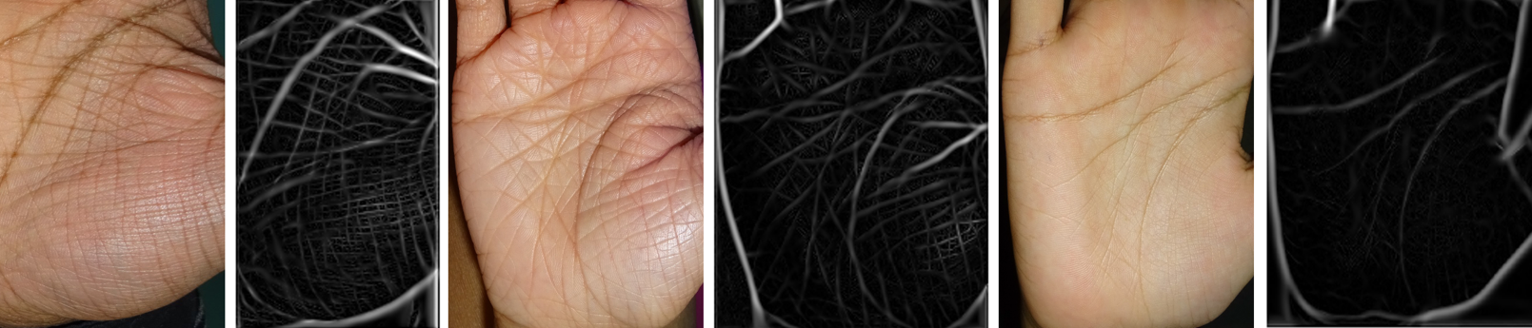

**Figure S3.** Computational hyperlinearity scores by clinical rating.

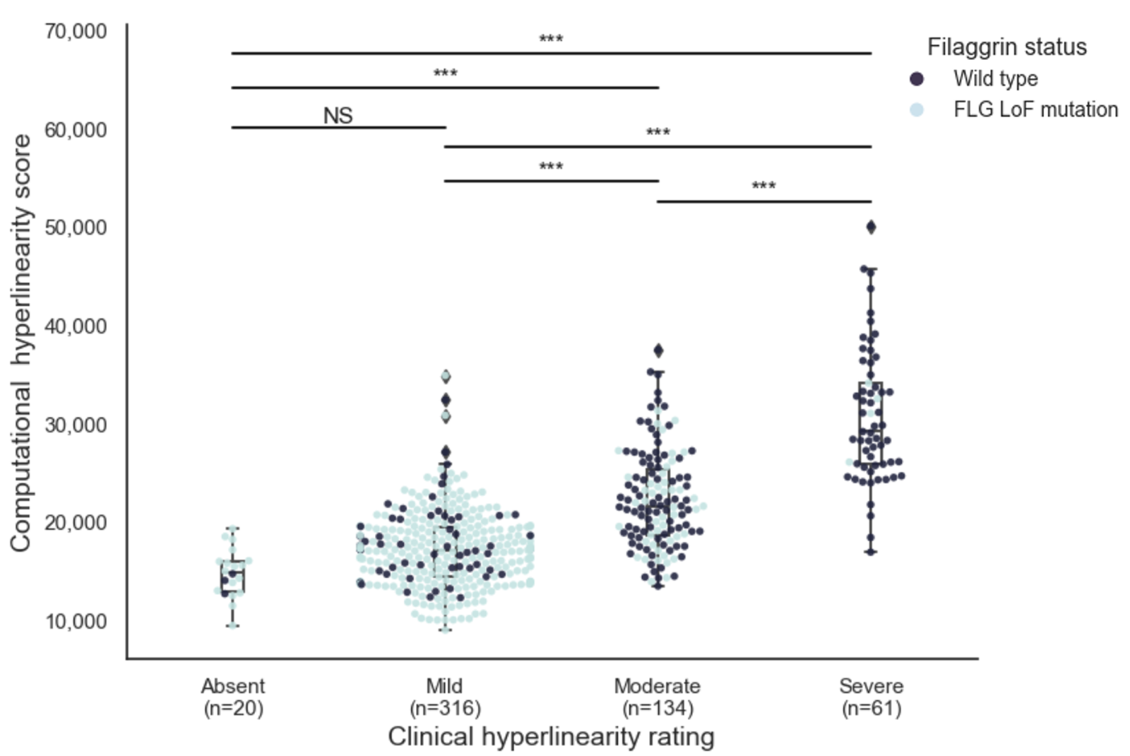

*** signifies p-value ≤0.001

NS = not significant (p >0.05)

Mean (standard deviation) scores for each clinical group were:

- absent 14 778 (±2398)

- mild 17 120 (±3779),

- moderate 22 240 (±4942)

- severe 30 703 (±6747)

**Figure S4.** (A) Computational hyperlinearity scores by 3 age groups, with filaggrin loss-of-function mutations indicated by hue of each case. (B) Computational hyperlinearity scores for each filaggrin mutation group presented separately by each of the 3 age groups. (C-D) The same analysis was repeated but using 4 age groups.

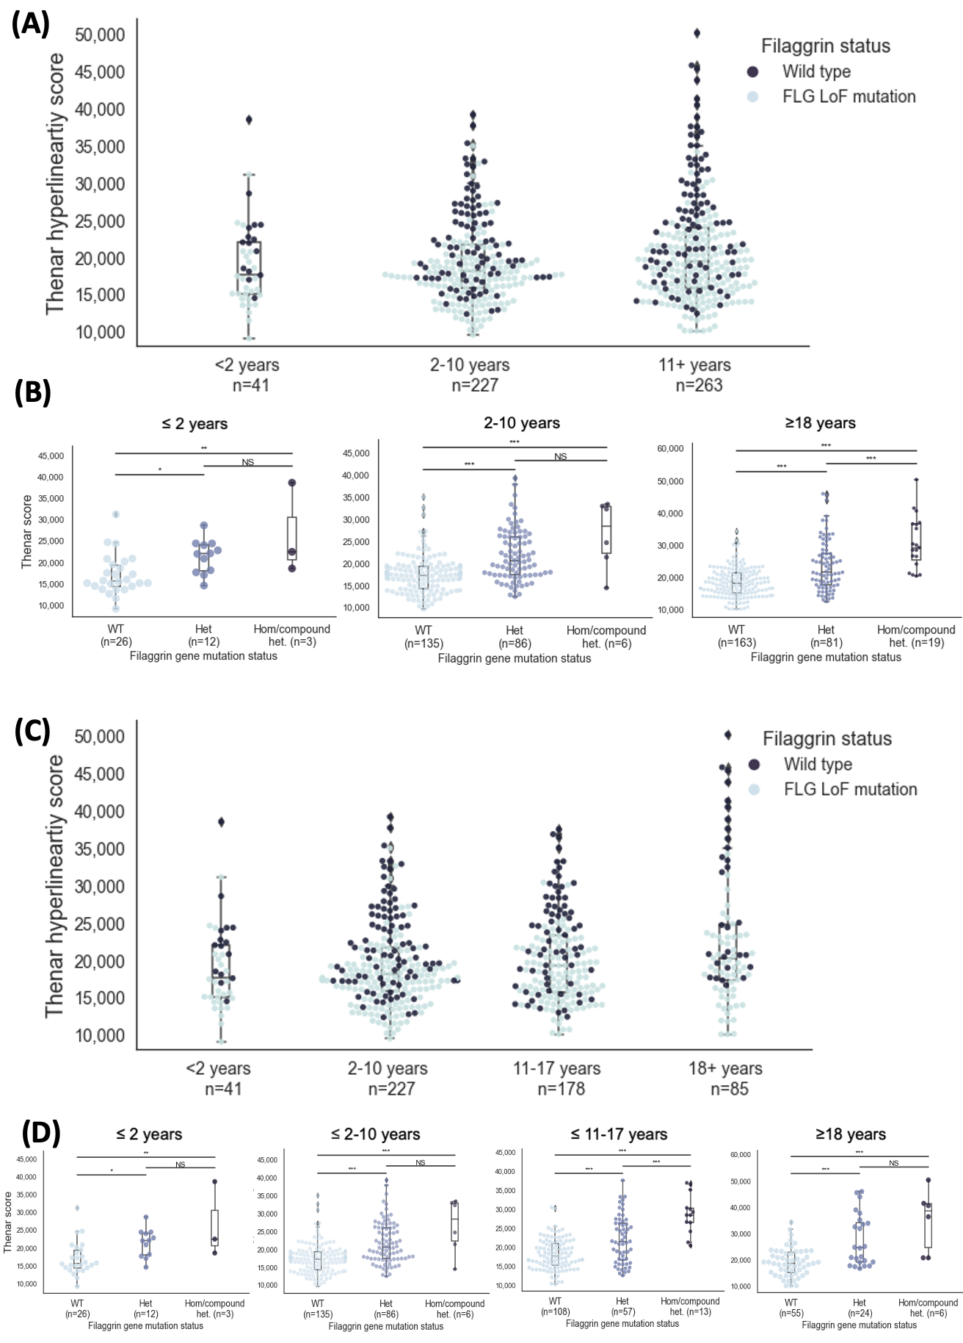

**Figure S5.** External images, along with their palmar hyperlinearity status described in the original paper, are shown for (A) 3 thenar eminence images, from Lowe et al.2 and (B) 3 palmar images, from Fukuie et al.3 (C-D) Generated scores were then mapped onto our distribution of scores (purple lines), which showed that “moderate-severe/apparent” palmar hyperlinearity appropriately scored highly in our distribution, whereas “mild”, “suspected, and “absent” palmar hyperlinearity had lower scores.

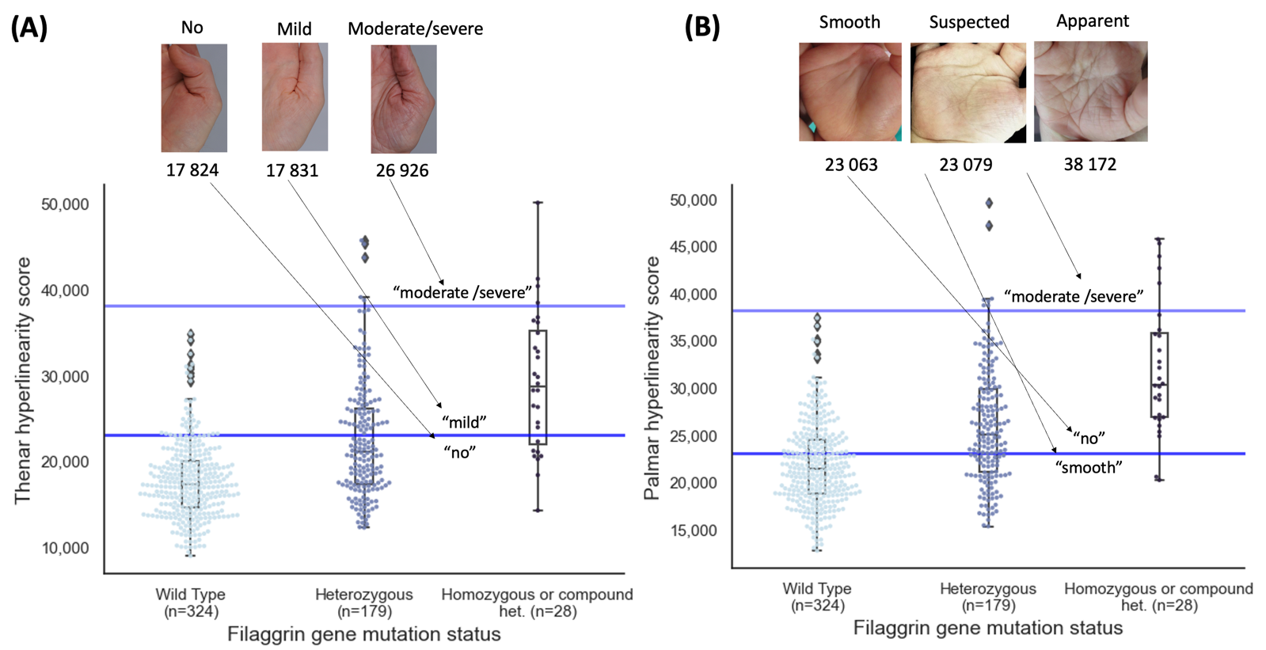

**Figure S6.** Computational thenar hyperlinearity scores by clinical hyperlinearity rating for non-atopic control individuals. Images were taken in a different setting to the original study.

